**PROJECT-LEVEL RESULTS FRAMEWORK**

**Project Theory of Change Narrative**

1. **Cause-and-Effect Linkages**

Counterpart’s Results Framework (Figures 1, 2, and 3 above) depict the causal linkages between each activity, intermediate results, and strategic outcomes (SOs) of the project. Our program design is multi-layered to encompass USDA’s three strategic objectives: MGD SO1 – Improved Literacy of School-Age Children, MGD SO2 – Increased Use of Health, Nutrition and Dietary Practices, and LRP SO1 – Improved Effectiveness of Food Assistance through Local and Regional Procurement. *Bridging the Future’s* theory of change (TOC) posits:

*If* children are provided with an **enabling environment** that sustainably maximizes learning outcomes, including skilled teachers and pupil support via extracurricular activities;

*If* children benefit from daily **nutritious school meals**, using effective procurement systems;

*If* schools are provided with targeted and needs-based **infrastructure improvements**;

*If* children and families use improved **health, nutrition, and hygiene practices**;

*If* **parents are engaged** in their children’s school and education,

*If* **government makes demonstrable progress to institutionalize interventions**,

*Then*, **literacy outcomes will improve** for children today and in the future.

Our TOCis built upon

* Kremer, Brannen, and Glennerster’s (2013) systematic review cites several effective practices to improving learning outcomes divided into the broad categories of increasing access to education – including preventative health and nutrition measures – and improving quality of education – including improved teacher training and pedagogical coaching.[1]
* Evidence that school feeding programs correlate to positive impacts on school participation, as measured through student attendance and enrollment.[2]
* Ganimiam and Murnane’s (2016) study, which found that community engagement through coaching parents about benefits of schooling, informing parents of factors of high-quality schooling, and guiding parents in using developmentally appropriate parenting practices increase student achievement.[3]
* Evidence that children’s literacy is predicated on an enabling environment at the school level, child well-being, and host-country government commitment and capacity for sustainability.[4]

1. **Critical Assumptions**

Our ability to achieve the intermediate results and long-term outcomes of the Results Framework depends on critical assumptions about the activities:

1. The project activities and local system will continue to support successful activities in existing schools and project activities can transfer to new intervention schools.
2. A sufficient number of teachers and school directors are employed and retained at each school for multiple years, to facilitate the transformation of practices to support children's learning, protection, and feeding.
3. Schools have access to safe drinking water within a reasonable geographical distance.
4. Community members participate in school governance and school-based activities.
5. The project’s school meals are delivered in a timely manner.
6. The Ministry of Education (MoE) will provide resources for school feeding programs.
7. Key stakeholders view the project’s activities and McGovern-Dole as non-controversial.
8. Project activities to engage PTA and SMC/COGES members will be sufficient to maintain their continued interest in taking a more active role in supporting children’s learning, protection, and feeding.

The following **external** **risks** could disrupt or negatively affect our ability to implement activities as planned and achieve the outcomes described in the Results Framework: (I) Disruptions to schooling (due to COVID-19, political instability, or teacher strikes); (ii) Climate change events including serious drought conditions leading to decreases in crop yield and household income that prevent parents from sending their children to school. (iii) Aggravation of wheat and fuel prices due to the war in Ukraine.

Our **MEL design and activities** are based on the following assumptions:

1. Access to schools is supported throughout the LOP.
2. School feeding, literacy, preventative health and nutrition, and LRP activities will occur in all project schools; infrastructure and rehabilitation activities will be dictated by school need; and other interventions will occur at the regional and national levels.
3. Teacher attrition and pupil movement between schools is comparable year over year (i.e., systematic biases are the same at each evaluation point).
4. The program design accounts for exposure to non-USDA interventions through selection criteria and therefore is not incorporated in MEAL design (e.g., sample stratification).
5. Needs assessment and GoM data will provide needed sampling and stratification information for sampling.
6. The project’s sustainability approach will be guided by and aligned with the World Bank-funded Education Sector Program Implementation Grant to Mauritania.[5]

**RESULTS FRAMEWORKS**

The following results frameworks display the project’s development hypothesis of activities leading to intermediate results and the three Strategic Objectives (SOs). Counterpart posits that LRP SO1 contributes to the achievement of MGD SO2 and both combined support the achievement of MGD SO1.

**Figure1: Results Framework (RF) #1 Improved Literacy of School Age Children**

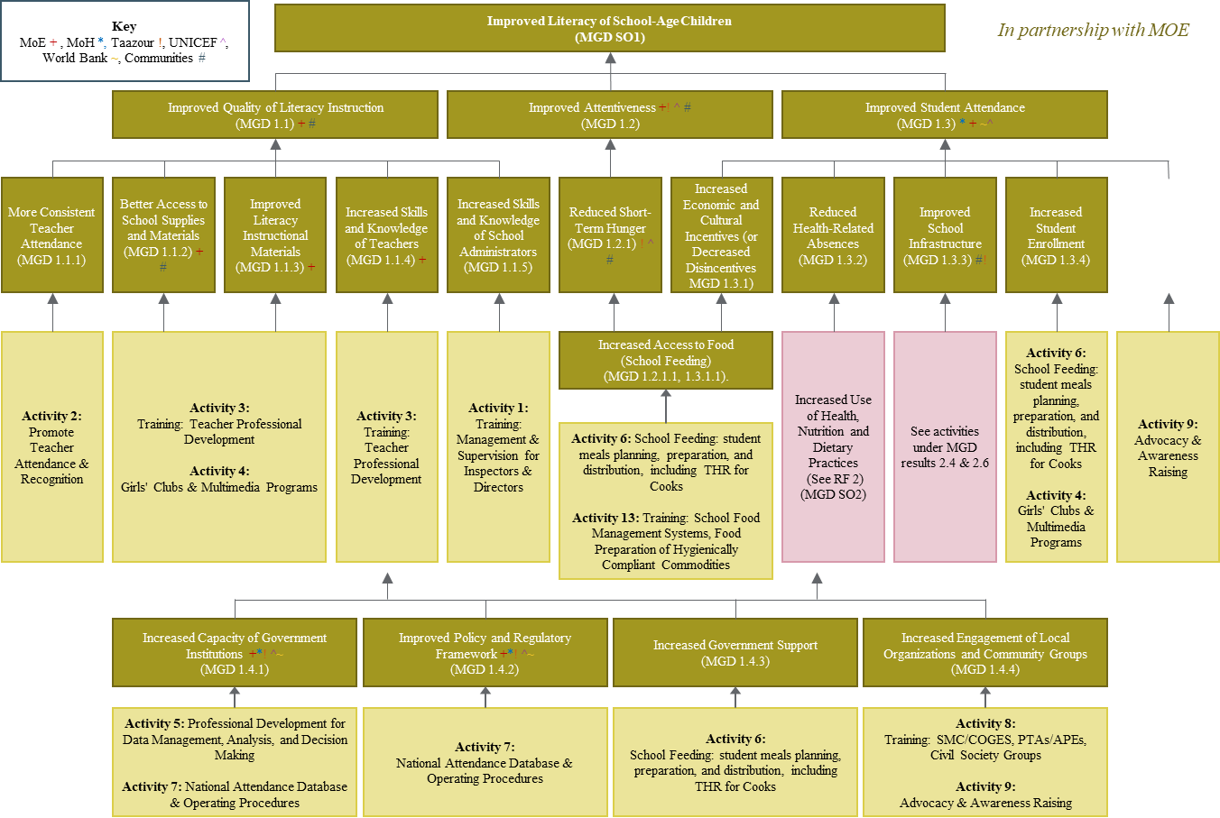

.

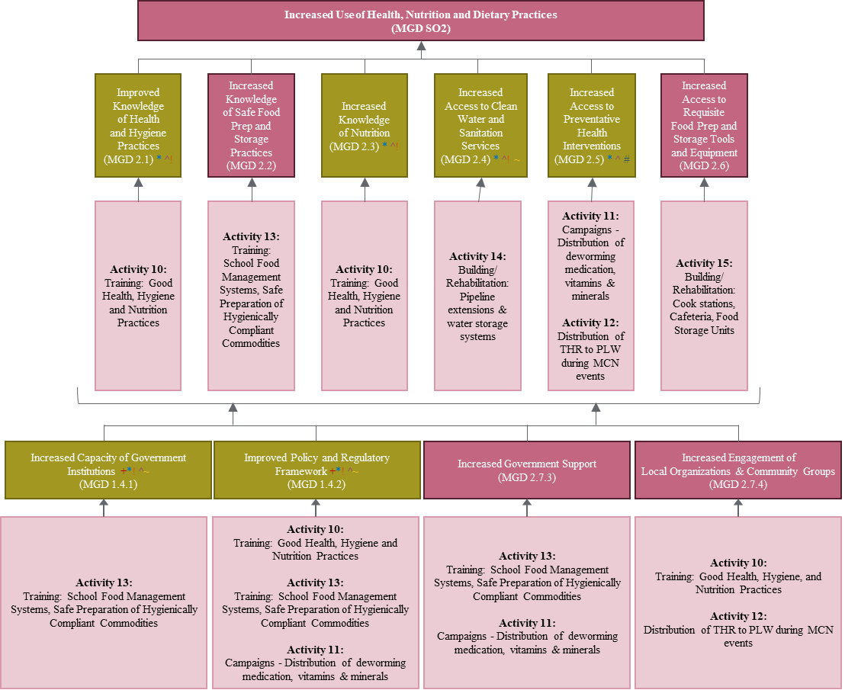**Figure 2: RF #2 Increased Use of Health, Nutrition, and Dietary Practices**

**Figure 3: LRP RF Improved Effectiveness of Food Assistance through Local & Regional Procurement**

1. Kremer, M., Brannen, C., & Glennerster, R. (2013). The challenge of education and learning in the developing world. Science, 340, 297-300. doi:10.1126/science.1235350
2. McGovern–Dole International Food for Education and Child Nutrition Program: A Learning Agenda (Feb 2016), 4.
3. Ganimian, A. J., & Murnane, R. J. (2016). Improving education in developing countries: Lessons from rigorous impact evaluations. Review of Educational Research, 86(3), 719-755. doi:10.3102/0034654315627499
4. USAID Reading Matters Conceptual Framework (Nov 2019). <https://www.globalreadingnetwork.net/sites/default/files/media/file/Reading%20MATTERS%20Conceptual%20Framework_v7_October%2026%20%281%29_final.pdf>
5. <https://www.globalpartnership.org/content/program-document-education-sector-program-implementation-grant-mauritania-2020>